1. **Baroque**

The Baroque is often thought of as a period of artistic style that used exaggerated motion and clear, easily interpreted detail to produce drama, tension, exuberance, and grandeur in sculpture, painting, architecture, literature, dance, theater, and music. The style began around 1600 in Rome, Italy, and spread to most of Europe.

The popularity and success of the Baroque style was encouraged by the Catholic Church, which had decided at the time of the Council of Trent, in response to the Protestant Reformation, that the arts should communicate religious themes in direct and emotional involvement.

The word baroque is derived from the Portuguese word "barroco", Spanish "barroco", or French "baroque", all of which refer to a "rough or imperfect pearl", though whether it entered those languages via Latin, Arabic, or some other source is uncertain.

The Baroque era is sometimes divided into roughly three phases for convenience:

* Early Baroque, c.1590–c.1625
* High Baroque, c.1625–c.1660
* Late Baroque, c.1660–c.1725

Late Baroque is also sometimes used synonymously with the succeeding Rococo movement.

Baroque style featured "exaggerated lighting, intense emotions, release from restraint, and even a kind of artistic sensationalism". Baroque art did not really depict the life style of the people at that time; however, "closely tied to the Counter-Reformation, this style melodramatically reaffirmed the emotional depths of the Catholic faith and glorified both church and monarchy" of their power and influence.

* 1. **Michelangelo Mersi da Caravaggio**

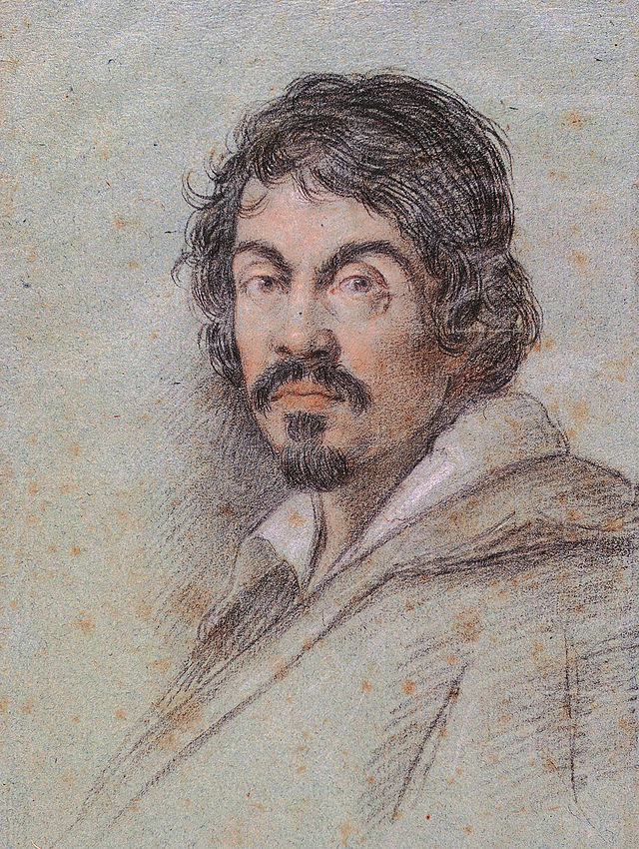

Michelangelo Merisi (or Amerighi) da Caravaggio (Milan, 29 September 1571 – 18 July 1610) was an Italian painter active in Rome, Naples, Malta, and Sicily between 1592 and 1610. His paintings, which combine a realistic observation of the human state, both physical and emotional, with a dramatic use of lighting, had a formative influence on Baroque painting.

Caravaggio trained as a painter in Milan under Simone Peterzano who had himself trained under Titian. In his twenties Caravaggio moved to Rome where there was a demand for paintings to fill the many huge new churches and palazzos being built at the time. It was also a period when the Church was searching for a stylistic alternative to Mannerism in religious art that was tasked to counter the threat of Protestantism. Caravaggio's innovation was a radical naturalism that combined close physical observation with a dramatic, even theatrical, use of chiaroscuro which came to be known as tenebrism (the shift from light to dark with little intermediate value).

Caravaggio "put the oscuro (shadows) into chiaroscuro." Chiaroscuro was practiced long before he came on the scene, but it was Caravaggio who made the technique a dominant stylistic element, darkening the shadows and transfixing the subject in a blinding shaft of light. With this came the acute observation of physical and psychological reality which formed the ground both for his immense popularity and for his frequent problems with his religious commissions. He worked at great speed, from live models, scoring basic guides directly onto the canvas with the end of the brush handle; very few of Caravaggio's drawings appear to have survived, and it is likely that he preferred to work directly on the canvas.

Caravaggio never married and had no known children, and Howard Hibbard notes the absence of erotic female figures from the artist's oeuvre: "In his entire career he did not paint a single female nude." On the other hand, the cabinet-pieces from the Del Monte period are replete with "full-lipped, languorous boys ... who seem to solicit the onlooker with their offers of fruit, wine, flowers - and themselves."

* + 1. **Basket of fruits**

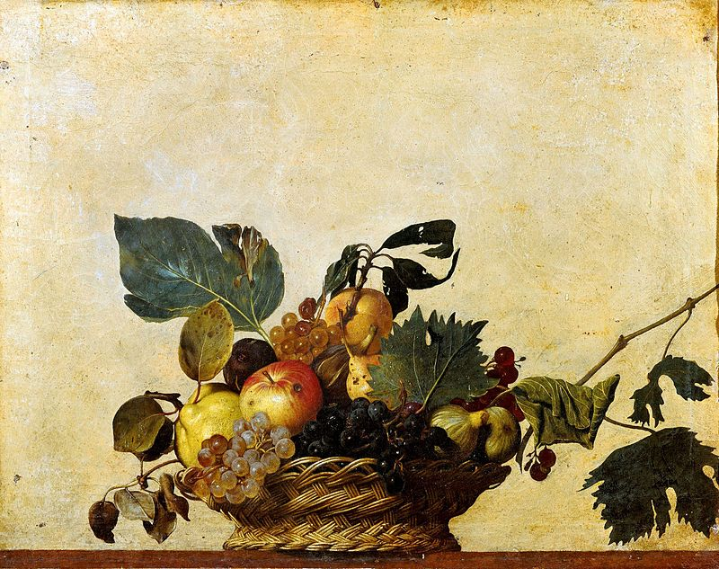

Basket of Fruit (c.1599) is a painting by the Italian Baroque master Michelangelo Merisi da Caravaggio (1571–1610), which hangs in the Biblioteca Ambrosiana (Ambrosian Library), Milan.

Type: oil on canvas.

It shows a wicker basket perched on the edge of a ledge. The basket contains a selection of summer fruit.

Much has been made of the worm-eaten, insect-predated, and generally less than perfect condition of the fruit. Possibly Caravaggio simply painted what was available; or possibly it has some meaning along the general lines of 'all things decay'; more specifically, there may be a reference to the Book of Amos 8:1-2: "This is what the Lord God showed me — a basket of summer fruit. He said, "Amos, what do you see?" And I said, "A basket of summer fruit." Then the Lord God said to me, "The end has come upon my people Israel; I will never again pass them by." (God is angry with Israel for neglecting the poor, and there may be a pun in Hebrew between 'basket of fruit' and 'the end').

* + 1. **The Young Sick Bacchus**

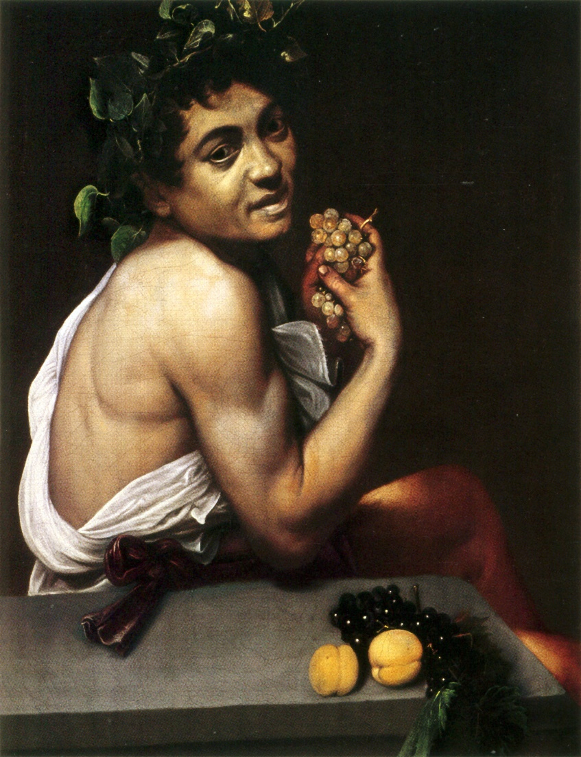

The Young Sick Bacchus (Italian: Bacchino Malato), also known as the Sick Bacchus or the Self-Portrait as Bacchus, is an early self-portrait by the Baroque artist Michelangelo Merisi da Caravaggio, dated between 1593 and 1594. It now hangs in the Galleria Borghese in Rome. According to Caravaggio's first biographer, Giovanni Baglione, it was a cabinet piece painted by the artist using a mirror.

Type: oil on canvas.

Sources for this period are inconclusive and probably inaccurate, but they agree that at one point the artist fell extremely ill and spent six months in the hospital of Santa Maria della Consolazione. According to a 2009 article in the American medical publication Clinical Infectious Diseases, the painting indicates that Caravaggio's physical ailment likely involved malaria, as the jaundiced appearance of the skin and the icterus in the eyes are indications of some active hepatic disease causing high levels of bilirubin.

Apart from its assumed autobiographical content, this early painting was likely used by Caravaggio to market himself, demonstrating his virtuosity in painting genres such as still-life and portraits and hinting at the ability to paint the classical figures of antiquity. The three-quarters angle of the face was among those preferred for late renaissance portraiture, but what is striking is the grimace and tilt of the head, and the very real sense of the suffering; a feature that most Baroque art shares.

* + 1. **Boy with a basket of fruits**

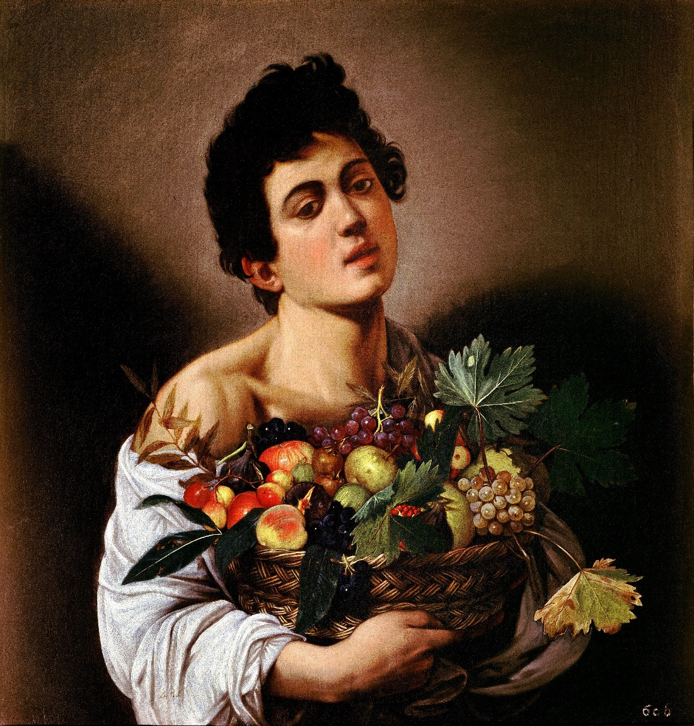

Boy with a Basket of Fruit, c.1593, is a painting generally ascribed to Italian Baroque master Michelangelo Merisi da Caravaggio, currently in the Galleria Borghese, Rome.

Type: oil on canvas.

The painting dates from the time when Caravaggio, newly arrived in Rome from his native Milan, was making his way in the competitive Roman art world. The model was his friend and companion, the Sicilian painter Mario Minniti, at about 16 years old.

At one level the painting is a genre piece designed to demonstrate the artist's ability to depict everything from the skin of the boy to the skin of a peach, from the folds of the robe to the weave of the basket.

* 1. **Peter Paul Rubens**

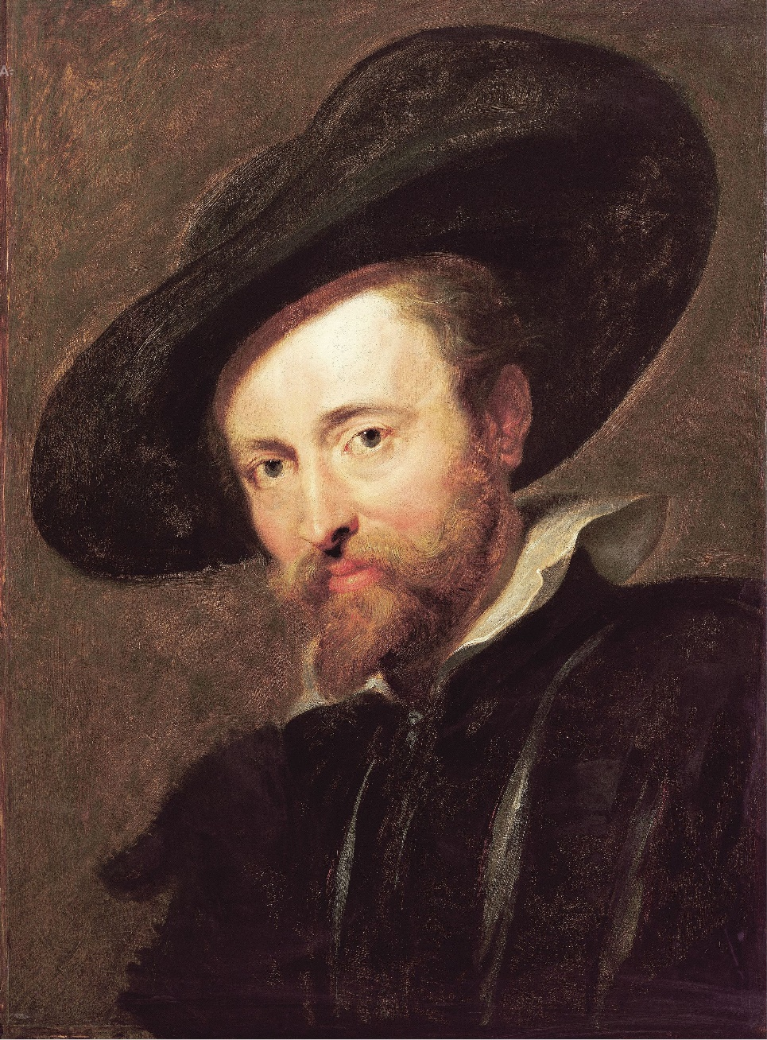

Sir Peter Paul Rubens (28 June 1577 – 30 May 1640) was a Flemish Baroque painter. A proponent of an extravagant Baroque style that emphasized movement, colour, and sensuality, Rubens is well known for his Counter-Reformation altarpieces, portraits, landscapes, and history paintings of mythological and allegorical subjects.

Rubens was a prolific artist. His commissioned works were mostly religious subjects, and "history" paintings, which included mythological subjects, and hunt scenes. He painted portraits, especially of friends, and self-portraits, and in later life painted several landscapes. Rubens designed tapestries and prints, as well as his own house.

His drawings are mostly extremely forceful but not overly detailed. His fondness of painting full-figured women gave rise to the terms 'Rubensian' or 'Rubenesque' for plus-sized women.

Paintings from Rubens' workshop can be divided into three categories: those he painted by himself, those he painted in part (mainly hands and faces), and those he only supervised as other painters produced them from his drawings or oil sketches.

* + 1. **Descent from the cross**

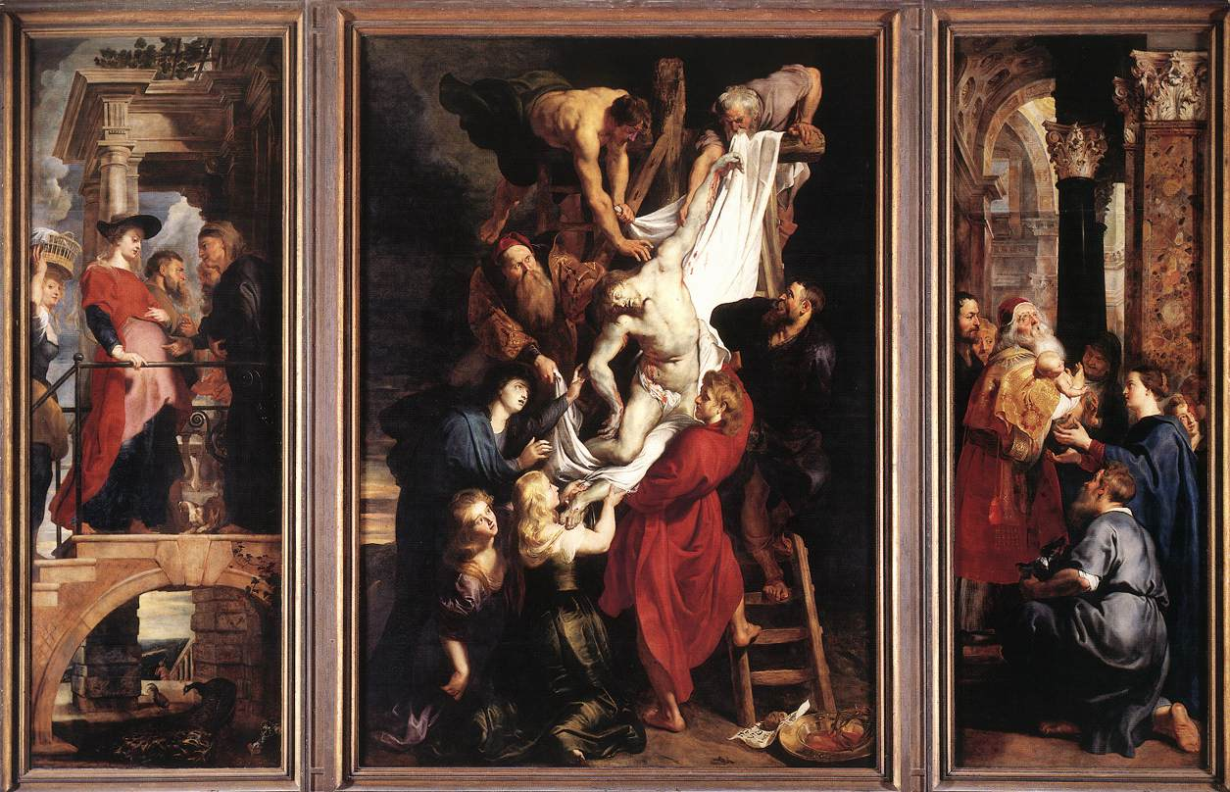

The Descent from the Cross, or Deposition of Christ, is the scene, as depicted in art, from the Gospels' accounts of Joseph of Arimathea and Nicodemus taking Christ down from the cross after his crucifixion (John 19:38-42). In Byzantine art the topic became popular in the 9th century, and in the West from the 10th century. The Descent from the Cross is the 13th Station of the Cross.

Even in early depictions the details and posing of the composition, and especially the position of Christ's body, are varied. The scene was usually included in medieval cycles of the Life or the Passion of Christ, between the Crucifixion and the Entombment of Christ. The Lamentation of Christ, or Pietà, showing the body of Christ held by Mary, may intervene between these two, and is common as an individual image, especially in sculpture. The Bearing of the body, showing Christ's body being carried to his tomb, and the Anointing of Christ's body, showing the body laid flat on the top of the tomb or a similarly-shaped "anointing-stone" are other scenes that may be shown. This last is especially important in Orthodox art, where it is shown on the Epitaphios.

With the Renaissance the subject became popular for altarpieces, partly because of the challenges of the composition, and the suitability of its vertical shape. It was painted several times by both Rubens and Rembrandt, who repeated one of his paintings (now in Munich) in a large print, his only one to be mainly engraved, as well as making two other etchings of the subject.

* + 1. **Samson and Delilah**

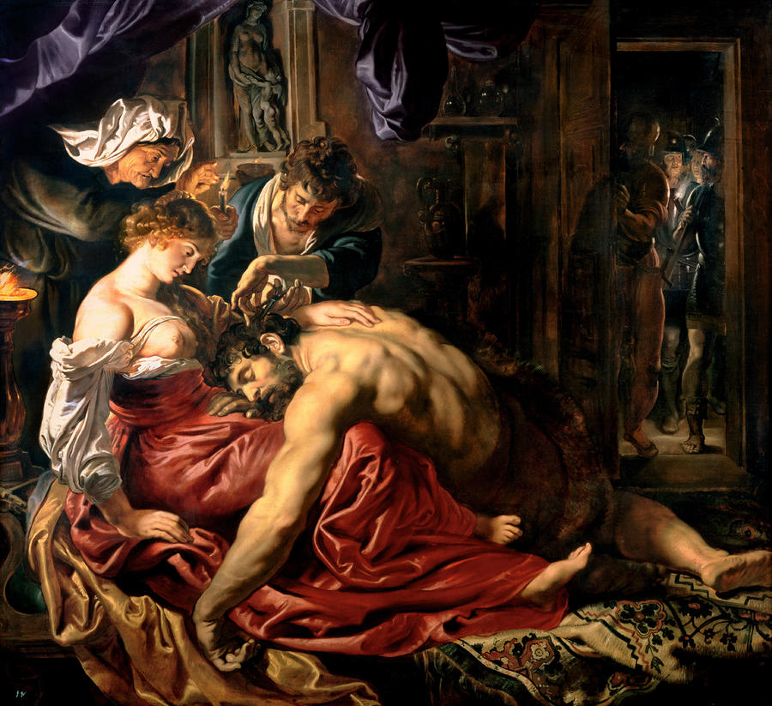

Samson and Delilah is a painting by the Flemish Baroque painter Peter Paul Rubens (1577–1640). It dates from about 1609 to 1610.

Type: oil on wood

The painting depicts an episode from the Old Testament story of Samson and Delilah (Judges 16). Samson, having fallen in love with Delilah, tells her the secret of his great strength: his uncut hair. Rubens portrays the moment, when having fallen asleep on Delilah's lap, a servant proceeds to cut Samson's hair. After, a weakened Samson is arrested by Philistine soldiers. The soldiers can be seen in the right-hand background of the painting.

The niche behind Delilah contains a statue of the Venus, the Goddess of love and her son, Cupid. This can be taken to represent the cause of Samson's fate. The old woman standing behind her, providing further light for the scene, does not appear in the biblical narrative of Samson and Delilah. She is believed to be a procuress, and the adjacent profiles of her and Delilah may symbolise the old woman's past, and Delilah's future. The Philistine cutting Samson's hair has his hands crossed as he cuts, this is a sign of deceit.

* + 1. **The Hippopotamus and Crocodile hunt**

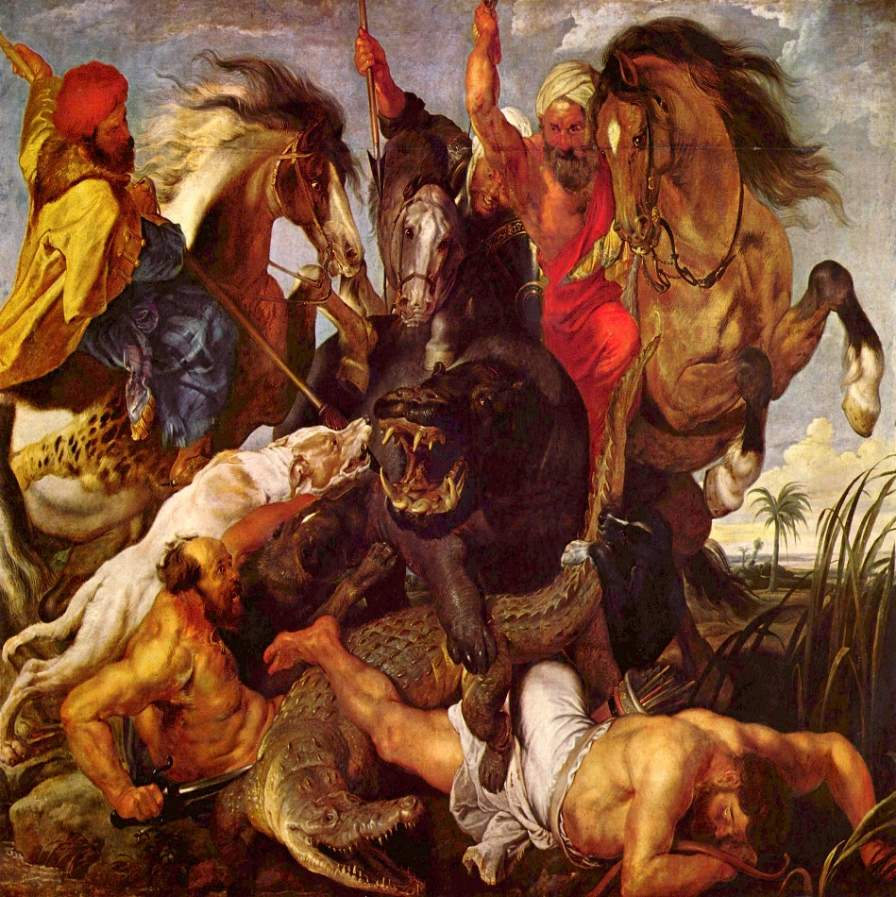

Type: oil on canvas

The Hippopotamus and Crocodile Hunt is a large painting by Peter Paul Rubens, featuring the hunt on hippopotamus and crocodile with three hunting dogs. There is also a reference to a leopard in the pelt on the horse of the upper left rider. Rubens used the dramatics of diagonals to heighten the sense of immediacy and movement and redirected attention downward into the center of action.

The Hippopotamus and Crocodile Hunt is one of the four hunting paintings, commissioned by Maximilian I, Elector of Bavaria to decorate the old Schleissheim Palace. After the seizure of this cycle during the Napoleonic Wars only The Hippopotamus and Crocodile Hunt was returned to Munich. In the notice of January 25, 1847 Eugène Delacroix admired the crocodile as a "masterpiece of execution", remarking, however, that "its action could have been more interesting".

* 1. **Rembrandt**

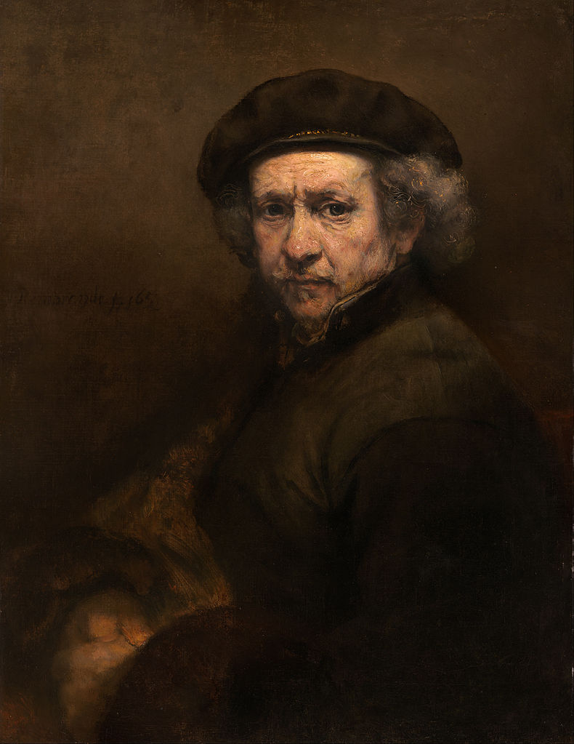

Rembrandt Harmenszoon van Rijn (15 July 1606[1] – 4 October 1669) was a Dutch painter and etcher. He is generally considered one of the greatest painters and printmakers in European art and the most important in Dutch history. His contributions to art came in a period of great wealth and cultural achievement that historians call the Dutch Golden Age when Dutch Golden Age painting, although in many ways antithetical to the Baroque style that dominated Europe, was extremely prolific and innovative, and gave rise to important new genres in painting.

Rembrandt's greatest creative triumphs are exemplified especially in his portraits of his contemporaries, self-portraits and illustrations of scenes from the Bible. His self-portraits form a unique and intimate biography, in which the artist surveyed himself without vanity and with the utmost sincerity.

Throughout his career Rembrandt took as his primary subjects the themes of portraiture, landscape and narrative painting. For the last, he was especially praised by his contemporaries, who extolled him as a masterly interpreter of biblical stories for his skill in representing emotions and attention to detail.

It was during Rembrandt's Leiden period (1625–1631) that Lastman's influence was most prominent. It is also likely that at this time Lievens had a strong impact on his work as well. Paintings were rather small, but rich in details (for example, in costumes and jewelry). Religious and allegorical themes were favored, as were tronies.

During his early years in Amsterdam (1632–1636), Rembrandt began to paint dramatic biblical and mythological scenes in high contrast and of large format seeking to emulate the baroque style of Rubens.

By the late 1630s Rembrandt had produced a few paintings and many etchings of landscapes. Often these landscapes highlighted natural drama, featuring uprooted trees and ominous skies.

In the decade following the Night Watch, Rembrandt's paintings varied greatly in size, subject, and style. The previous tendency to create dramatic effects primarily by strong contrasts of light and shadow gave way to the use of frontal lighting and larger and more saturated areas of color.

In the 1650s, Rembrandt's style changed again. Colors became richer and brush strokes more pronounced.

* + 1. **Philosopher in meditation**

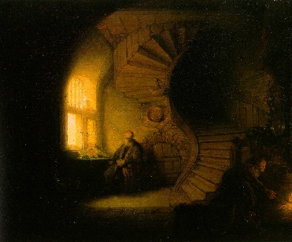

Philosopher in Meditation (Bredius 431) is the traditional title of an oil painting in the Musée du Louvre, Paris, that has long been attributed to the 17th-century Dutch artist Rembrandt.

Type: oil on oak

The painting depicts in slightly accelerated perspective two figures in a partially vaulted interior that is dominated by a wooden spiral staircase. The architecture includes stone, brick and wood, with arched elements (window, vault, doors) that create an impression of monumentality.

The presumed subject matter, the finely graded chiaroscuro treatment and intricate composition were widely appreciated in France and the painting is mentioned in the writings of many 19th- and 20th-century literary figures.

On the pre-iconographic level, this is one of the most "graphic" works painted by Rembrandt, in the sense that it contains many straight, curved, circular, and radiating lines: from the lines of the flagstones to those of the window, the bricks, the wainscotting, and of course the staircase. As in the staircase and the basketwork tray at the center of the composition, the curved lines can be said to organize the straight lines. As it is, the overall painting is quite dark due to the aging of the varnish.

* + 1. **The Anatomy lesson**

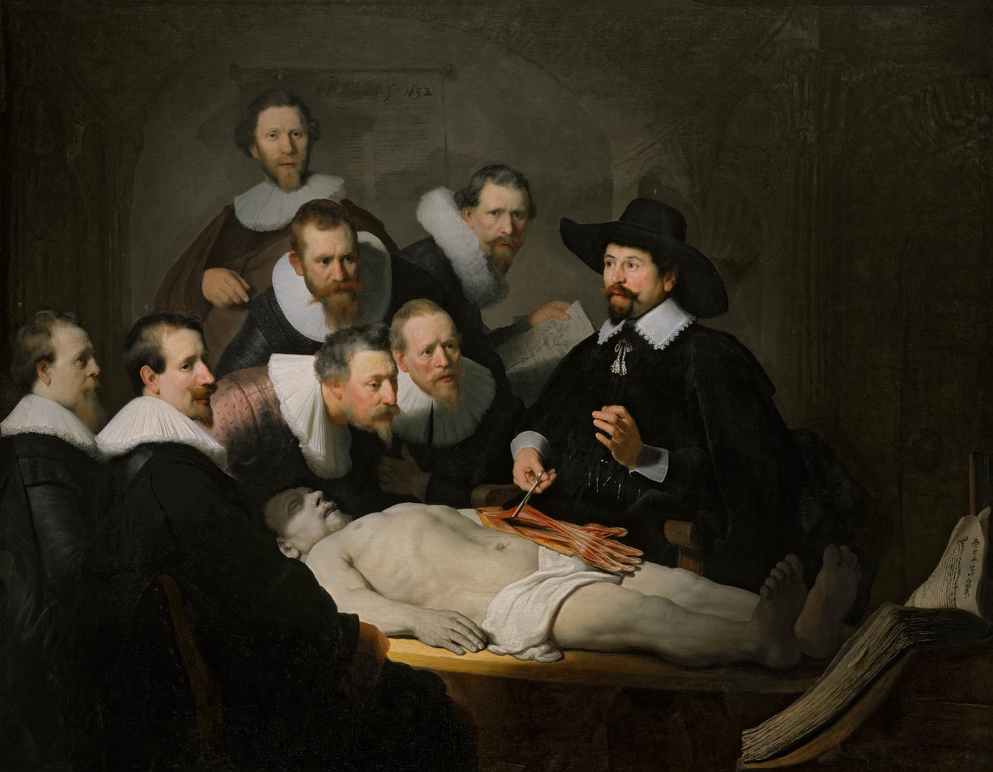

The Anatomy Lesson of Dr. Nicolaes Tulp is a 1632 oil painting on canvas by Rembrandt housed in the Mauritshuis museum in The Hague, the Netherlands. Dr. Nicolaes Tulp is pictured explaining the musculature of the arm to medical professionals. Some of the spectators are various doctors who paid commissions to be included in the painting.

Type: oil on canvas

The event can be dated to 16 January 1632: the Amsterdam Guild of Surgeons, of which Tulp was official City Anatomist, permitted only one public dissection a year, and the body would have to be that of an executed criminal. The face of the corpse is partially shaded, a suggestion of umbra mortis (shadow of death), a technique that Rembrandt was to use frequently.

Anatomy lessons were a social event in the 17th century, taking place in lecture rooms that were actual theatres, with students, colleagues and the general public being permitted to attend on payment of an entrance fee. The spectators are appropriately dressed for a solemn social occasion. It is thought that the uppermost (not holding the paper) and farthest left figures were added to the picture later.

* + 1. **The Night Watch**

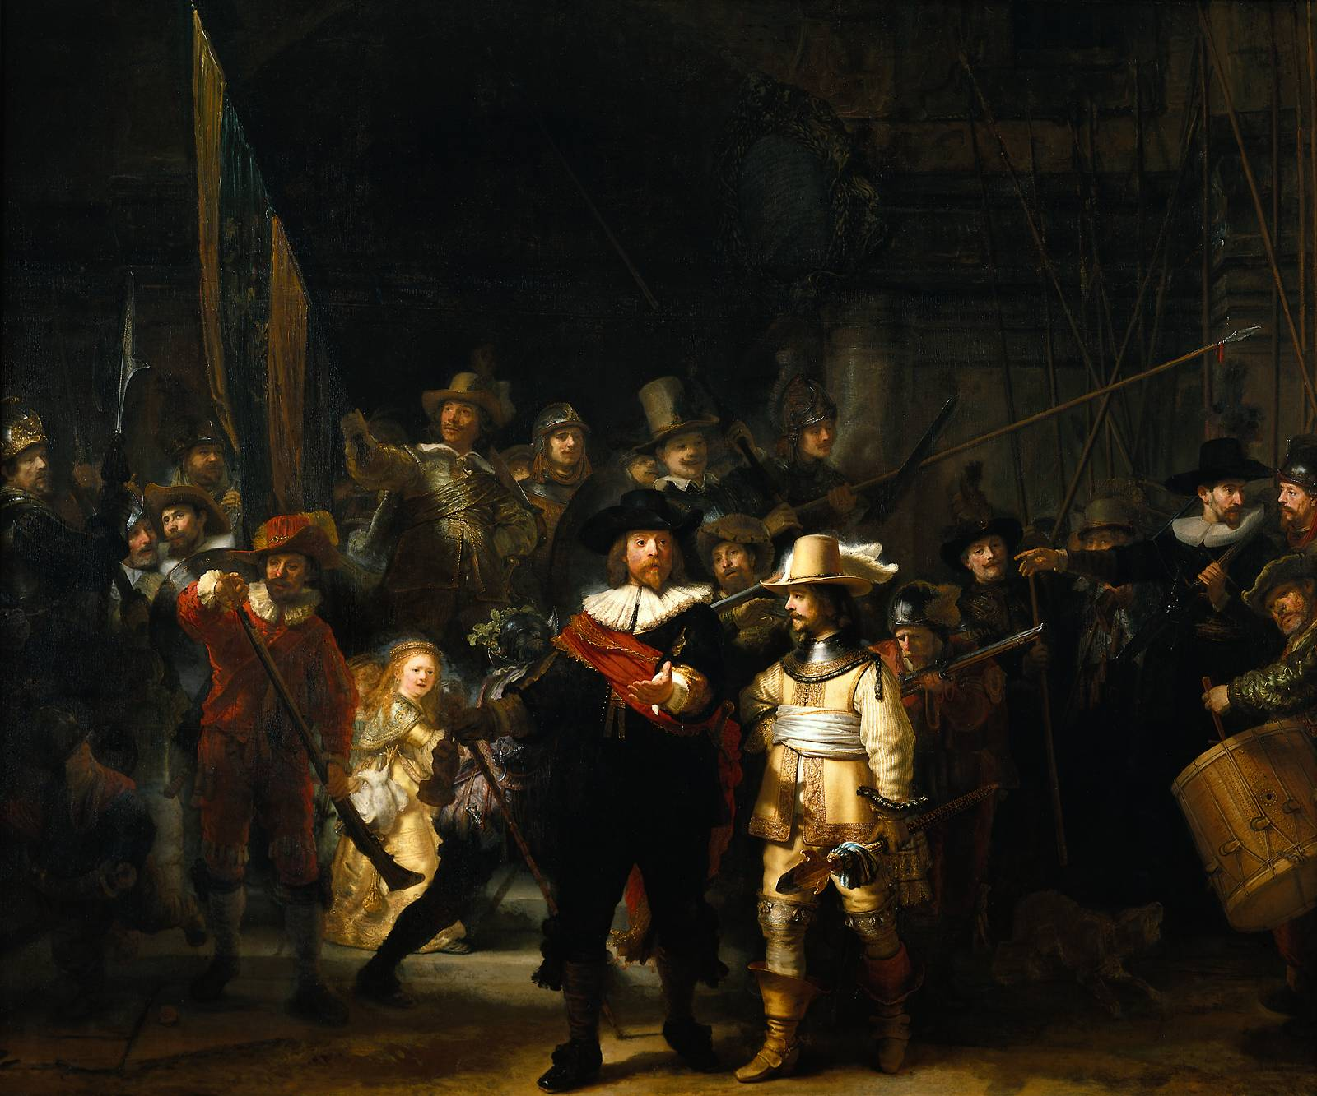

Militia Company of District II under the Command of Captain Frans Banninck Cocq, also known as The Shooting Company of Frans Banning Cocq and Willem van Ruytenburch, but commonly referred to as The Night Watch (Dutch: De Nachtwacht), is a 1642 painting by Rembrandt van Rijn. The Night Watch is a world renowned example of Baroque art.

Type: oil on canvas

The painting is renowned for three characteristics: its colossal size (363 cm × 437 cm (11.91 ft × 14.34 ft)), the effective use of light and shadow (chiaroscuro), and the perception of motion in what would have traditionally been a static military portrait.

It depicts the eponymous company moving out, led by Captain Frans Banning Cocq (dressed in black, with a red sash) and his lieutenant, Willem van Ruytenburch (dressed in yellow, with a white sash). With effective use of sunlight and shade, Rembrandt leads the eye to the three most important characters among the crowd, the two gentlemen in the centre (from whom the painting gets its original title), and the small girl in the centre left background. Behind them, the company's colours are carried by the ensign, Jan Visscher Cornelissen.

Rembrandt has displayed the traditional emblem of the Arquebusiers in the painting in a natural way: the girl in yellow dress in the background is carrying the main symbols. She is a kind-of mascot herself: the claws of a dead chicken on her belt represent the clauweniers (arquebusiers); the pistol behind the chicken stands for 'clover'; and, she is holding the militia's goblet. The man in front of her is wearing a helmet with an oak leaf, a traditional motif of the Arquebusiers. The dead chicken is also meant to represent a defeated adversary. The colour yellow is often associated with victory.

* 1. **Diego Velazquez**

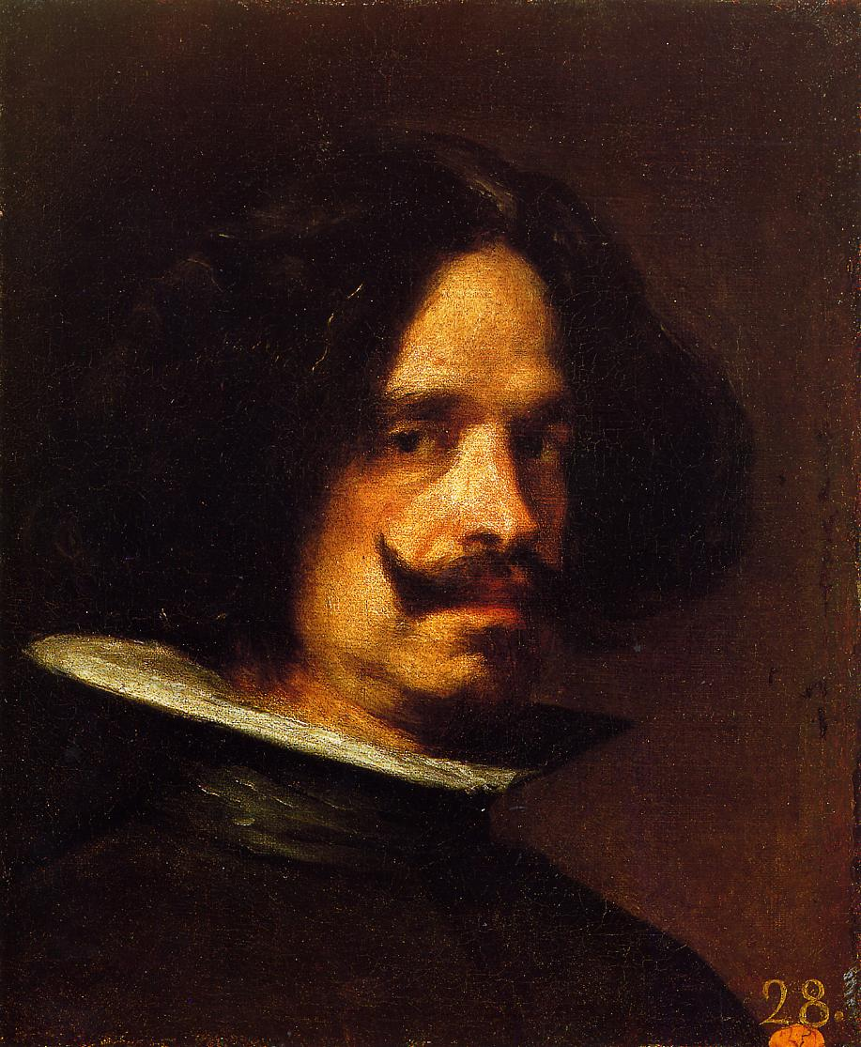

Diego Rodríguez de Silva y Velázquez (baptized on June 6, 1599 – August 6, 1660) was a Spanish painter who was the leading artist in the court of King Philip IV and one of the most important painters of the Spanish Golden Age. He was an individualistic artist of the contemporary Baroque period, important as a portrait artist. In addition to numerous renditions of scenes of historical and cultural significance, he painted scores of portraits of the Spanish royal family, other notable European figures, and commoners, culminating in the production of his masterpiece Las Meninas (1656).

From the first quarter of the nineteenth century, Velázquez's artwork was a model for the realist and impressionist painters, in particular Édouard Manet. Since that time, famous modern artists, including Pablo Picasso, Salvador Dalí and Francis Bacon, have paid tribute to Velázquez by recreating several of his most famous works.

Besides the forty portraits of Philip by Velázquez, he painted portraits of other members of the royal family: Philip's first wife, Elisabeth of Bourbon, and her children, especially her eldest son, Don Baltasar Carlos, of whom there is a beautiful full-length in a private room at Buckingham Palace. Cavaliers, soldiers, churchmen, and the poet Francisco de Quevedo (now at Apsley House), sat for Velázquez.

* + 1. **Las Meninas**

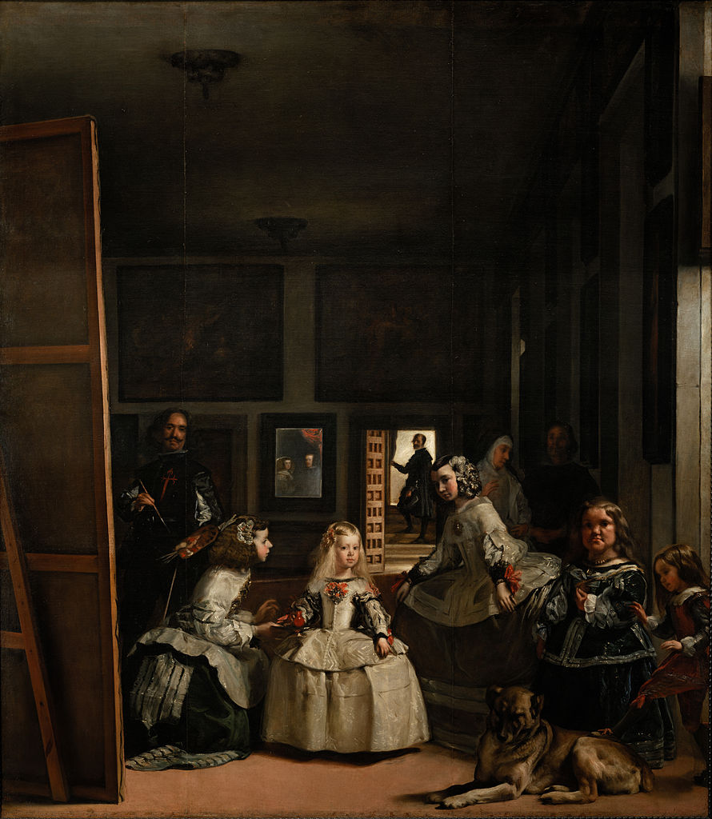

Las Meninas (Spanish for The Maids of Honour) is a 1656 painting by Diego Velázquez, the leading artist of the Spanish Golden Age, in the Museo del Prado in Madrid. The work's complex and enigmatic composition raises questions about reality and illusion, and creates an uncertain relationship between the viewer and the figures depicted. Because of these complexities, Las Meninas has been one of the most widely analyzed works in Western painting.

Type: oil on canvas

The painting shows a large room in the Royal Alcazar of Madrid during the reign of King Philip IV of Spain, and presents several figures, most identifiable from the Spanish court, captured, according to some commentators, in a particular moment as if in a snapshot. Some look out of the canvas towards the viewer, while others interact among themselves. The young Infanta Margaret Theresa is surrounded by her entourage of maids of honour, chaperone, bodyguard, two dwarfs and a dog. Just behind them, Velázquez portrays himself working at a large canvas. Velázquez looks outwards, beyond the pictorial space to where a viewer of the painting would stand. In the background there is a mirror that reflects the upper bodies of the king and queen. They appear to be placed outside the picture space in a position similar to that of the viewer, although some scholars have speculated that their image is a reflection from the painting Velázquez is shown working on.

Las Meninas has long been recognised as one of the most important paintings in Western art history.

* + 1. **Rokeby Venus**

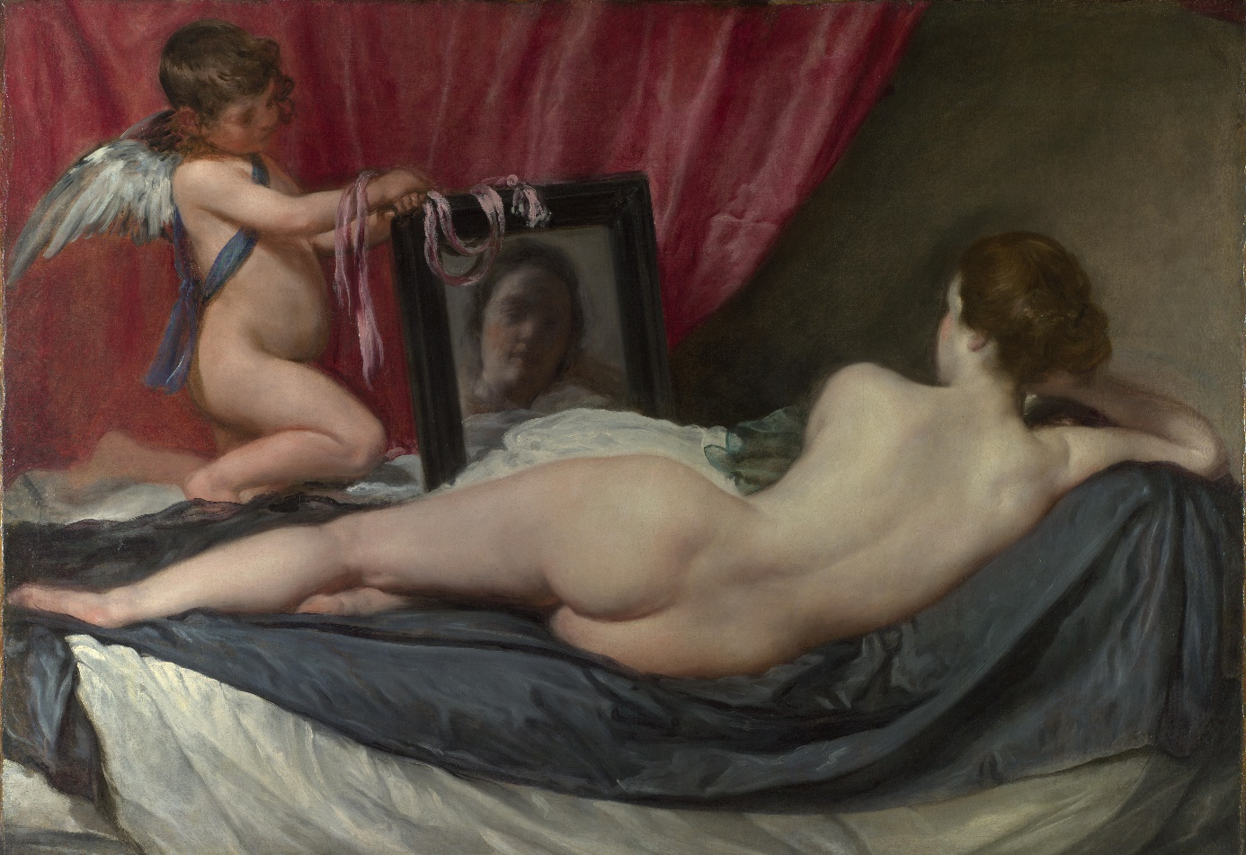

The Rokeby Venus (also known as The Toilet of Venus, Venus at her Mirror, Venus and Cupid, or La Venus del espejo) is a painting by Diego Velázquez (1599–1660), the leading artist of the Spanish Golden Age. Completed between 1647 and 1651, and probably painted during the artist's visit to Italy, the work depicts the goddess Venus in a sensual pose, lying on a bed and looking into a mirror held by the Roman god of physical love, her son Cupid. The painting is in the National Gallery, London.

Numerous works, from the ancient to the baroque, have been cited as sources of inspiration for Velázquez. The nude Venuses of the Italian painters, such as Giorgione's Sleeping Venus (c. 1510) and Titian's Venus of Urbino (1538), were the main precedents. In this work, Velázquez combined two established poses for Venus: recumbent on a couch or a bed, and gazing at a mirror. She is often described as looking at herself on the mirror, although this is physically impossible since viewers can see her face reflected in their direction. This phenomenon is known as the Venus effect. In a number of ways the painting represents a pictorial departure, through its central use of a mirror, and because it shows the body of Venus turned away from the observer of the painting.

The Rokeby Venus is the only surviving female nude by Velázquez. Nudes were extremely rare in seventeenth-century Spanish art, which was policed actively by members of the Spanish Inquisition.

* + 1. **The Surrender of Breda**

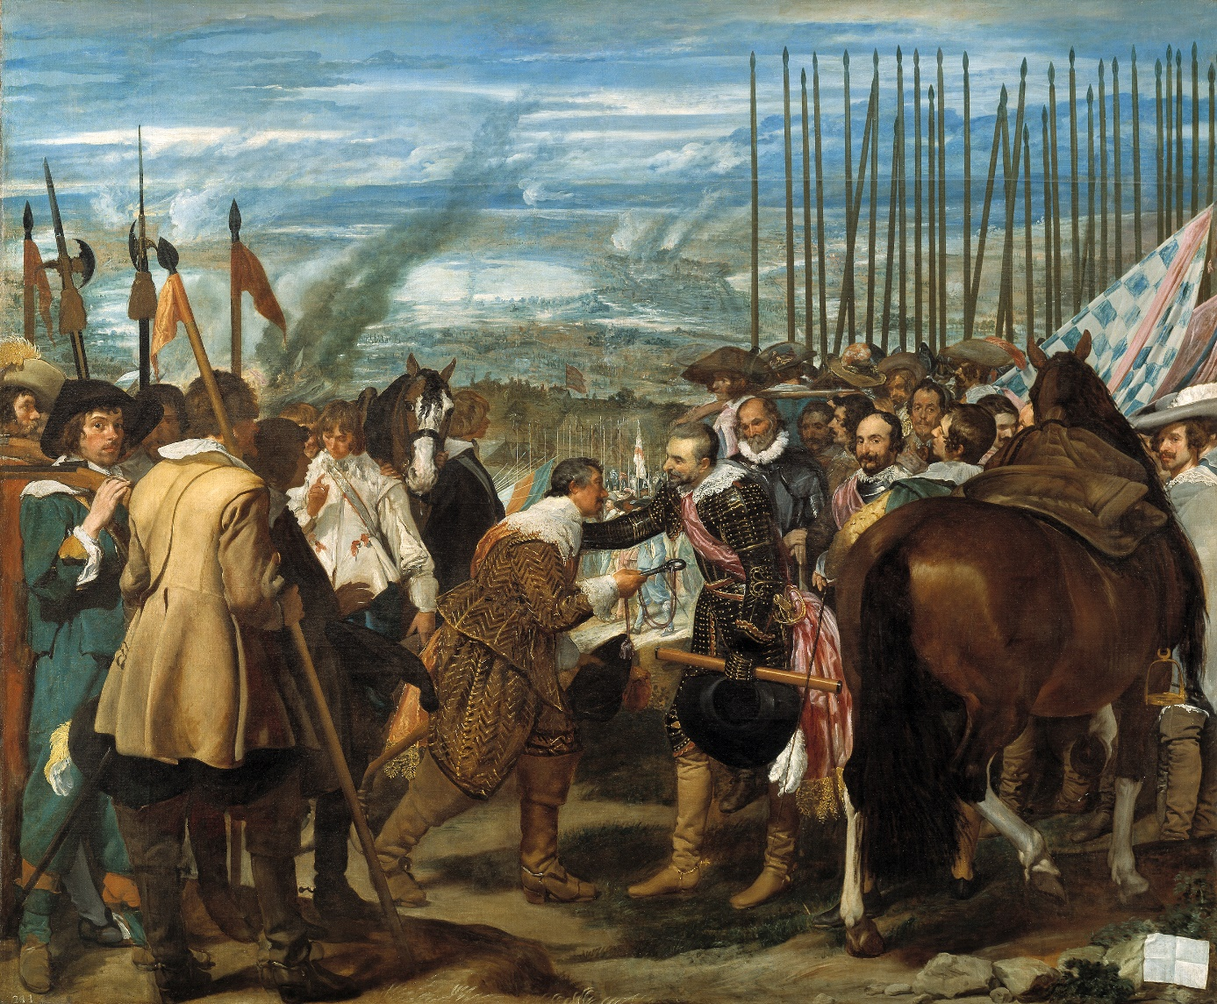

La rendición de Breda (English: The Surrender of Breda, also known as El cuadro de las lanzas or Las lanzas) is a painting by the Spanish Golden Age painter Diego Velázquez. It was completed during the years 1634–35, inspired by Velázquez's visit to Italy with Ambrogio Spinola, the Genoese general who conquered Breda on June 5, 1625. It is considered one of Velázquez's best works. Jan Morris has called it "one of the most Spanish of all pictures".

Type: oil on canvas

The Surrender of Breda was one of twelve life-size battle scenes intended to perpetuate victories won by Philip IV’s armies that hung in the Salón de Reinos in Buen Retiro. It illustrates the exchange of keys that occurred three days after the capitulation between Spain and the Netherlands was signed on June 5, 1625. Hence, the focus of the painting is not on the battle itself, but rather the reconciliation. At the center of the painting, literally and figuratively, is the key given to Spinola by Justin of Nassau. The key is “the precise center of his design, [enclosing] it in an emphatic parallelogram so that it becomes the focus of the entire large canvas—literally the key to the composition, locking all other components into place.” This battle painting is notable for its static and sentimental qualities.

1. **Expressionism**

Expressionism was a modernist movement, initially in poetry and painting, originating in Germany at the beginning of the 20th century. Its typical trait is to present the world solely from a subjective perspective, distorting it radically for emotional effect in order to evoke moods or ideas. Expressionist artists sought to express meaning or emotional experience rather than physical reality.

Expressionism was developed as an avant-garde style before the First World War. The term is sometimes suggestive of angst. The Expressionist emphasis on individual perspective has been characterized as a reaction to positivism and other artistic styles such as Naturalism and Impressionism.

While the word expressionist was used in the modern sense as early as 1850, its origin is sometimes traced to paintings exhibited in 1901 in Paris by an obscure artist Julien–Auguste Hervé, which he called Expressionismes. Though an alternate view is that the term was coined by the Czech art historian Antonin Matějček in 1910, as the opposite of impressionism: "An Expressionist wishes, above all, to express himself... (an Expressionist rejects) immediate perception and builds on more complex psychic structures... Impressions and mental images that pass through mental peoples soul as through a filter which rids them of all substantial accretions to produce their clear essence [...and] are assimilated and condense into more general forms, into types, which he transcribes through simple short-hand formulae and symbols."

* 1. **Edvard Munch**

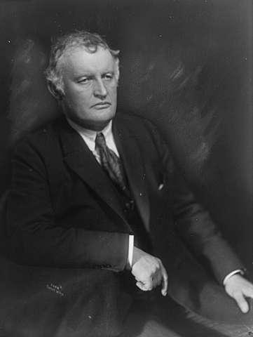

Edvard Munch (12 December 1863 – 23 January 1944) was a Norwegian painter and printmaker whose intensely evocative treatment of psychological themes built upon some of the main tenets of late 19th-century Symbolism and greatly influenced German Expressionism in the early 20th century. One of his most well-known works is The Scream of 1893.

In 1885, Edvard Munch traveled to Paris, and was extremely influenced by impressionism artists Claude Monet, Edouard Manet, and followed by the post-impressionism artists Van Gogh, Paul Cezanne, and Gauguin. In fact, the main style of Munch's work is post-impressionism, and focused on this style.

„Nature is not only all that is visible to the eye... it also includes the inner pictures of the soul.”

Much of the work which Edvard Munch created, was referred to as the style known as symbolism. This is mainly because of the fact that the pieces which he created, and the paintings he made, focused on the internal view of the objects, as opposed to the exterior, and what the eye could see. He would design many of his pieces around the way he felt, or the emotions he was repressing, which caused his work to showcase inward feeling, and more of a personal sense of art, as opposed to the external view, and the way everyone else would see the piece which he was portraying in any piece that he was designing.

* + 1. **The Scream**

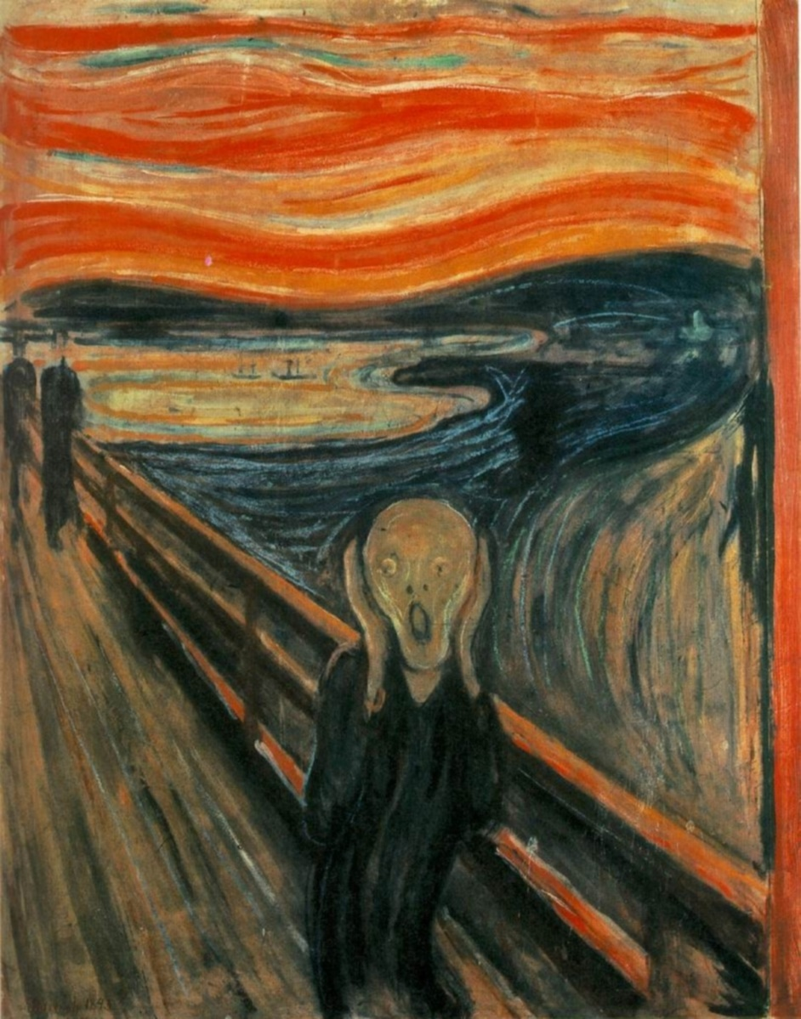

The Scream (Norwegian: Skrik) is the popular name given to each of four versions of a composition, created as both paintings and pastels, by the Expressionist artist Edvard Munch between 1893 and 1910. Der Schrei der Natur (The Scream of Nature) is the title Munch gave to these works, all of which show a figure with an agonized expression against a landscape with a tumultuous orange sky. Arthur Lubow has described The Scream as "an icon of modern art, a Mona Lisa for our time."

Edvard Munch created the four versions in various media. The fourth version (pastel, 1895) was sold for $119,922,600 at Sotheby's Impressionist and Modern Art auction on 2 May 2012 to financier Leon Black, the second highest nominal price paid for a painting at auction. The Scream has been the target of several high-profile art thefts. In 1994, the version in the National Gallery was stolen. It was recovered several months later. In 2004, both The Scream and Madonna were stolen from the Munch Museum, and were both recovered two years later.

In his diary in an entry headed, Nice 22 January 1892, Munch described his inspiration for the image:

„One evening I was walking along a path, the city was on one side and the fjord below. I felt tired and ill. I stopped and looked out over the fjord—the sun was setting, and the clouds turning blood red. I sensed a scream passing through nature; it seemed to me that I heard the scream. I painted this picture, painted the clouds as actual blood. The color shrieked. This became The Scream.“

* + 1. **The Day After**

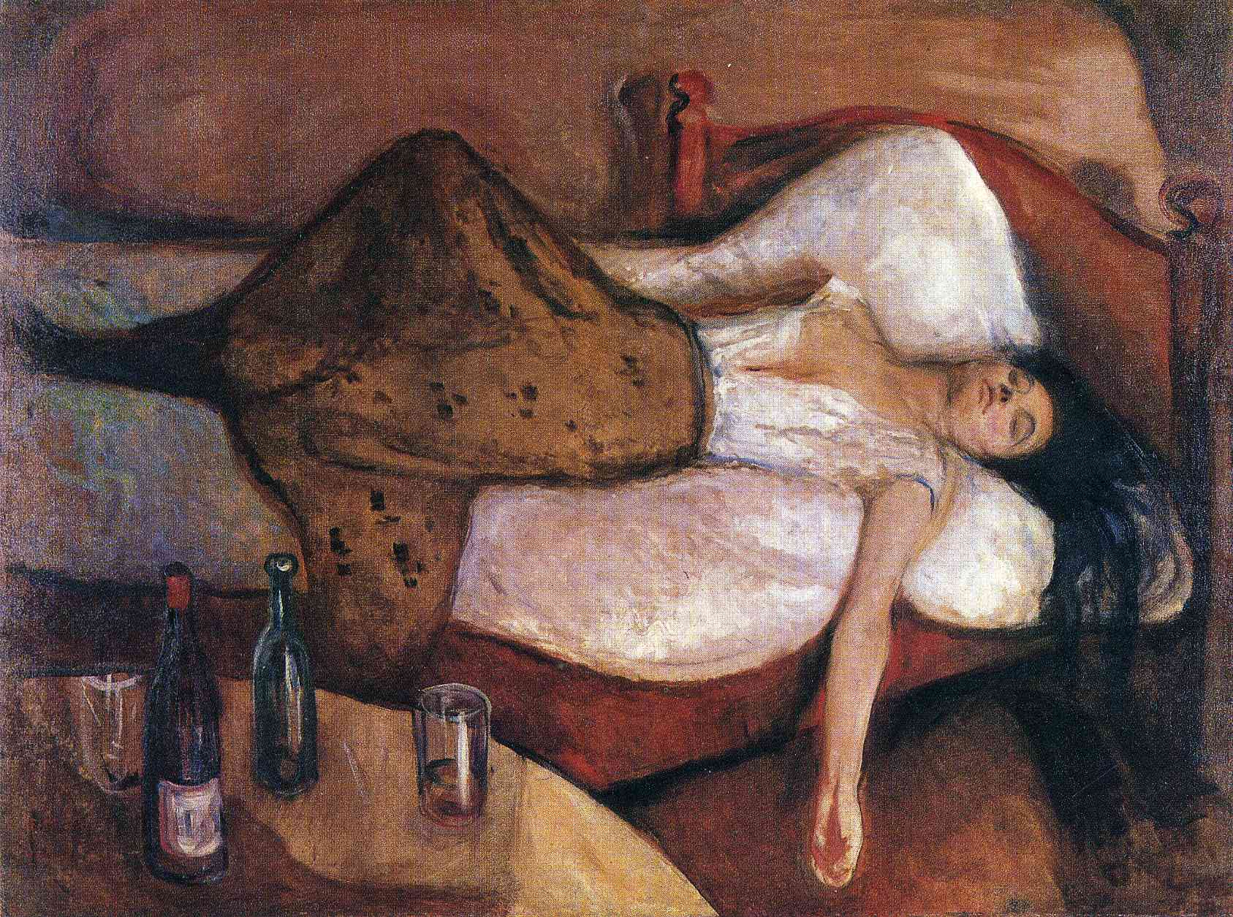

When Jens Thiis bought this picture for the National Gallery, Oslo, in 1909 the public was shocked; one critic denounced it as portraying a drunken prostitute. This is unlikely to have been Munch's idea. He did paint several pictures of prostitutes, tending to depict them as unattractive or even grotesque, whereas this woman closely resembles the Madonna and, different though the setting, shares her ethereal beauty. She is probably intended to illustrate one aspect of the essence of protean womanhood portrayed in that work. Both paintings in fact relate to a lost picture by Munch that Hans Jaeger had with him in his prison cell when jailed in 1886 for publishing From Christiania's Bohemia, a novel in which descriptions of free bohemian life parallel what is shown here. The present picture is more directly a replica, modified by his style of the 1890s, of the same subject painted in 1885-86 and also lost. One important Norwegian precedent for the depiction of a dissolute woman would undoubtedly have been known to Munch, Hans Heyerdahl's tiny, exquisite painting of The Champagne Girl, which was also strongly attacked when exhibited. If Munch's picture represents The Day After, Heyerdahl's might be called 'The Evening Before.'

* + 1. **Madonna**

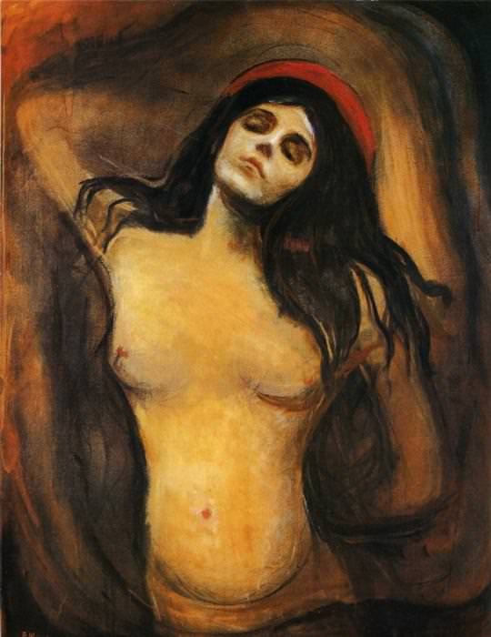

Originally called Loving Woman, this picture can be taken to symbolize what Munch considered the essential acts of the female life cycle: sexual intercourse, causing fertilization, procreation and death. Evidence for the first is in the picture itself, an intensified, spiritualized variation in the nude of the 'mating' pose, the woman depicted as though recumbent beneath her lover. The ethereal beauty of her face was said to resemble both Dagny Przybyszewska and her sister Ragnhild Backstrom. Procreation was implied by the decoration of the original frame, later discarded, on which were painted drops of semen and an embryo. That Munch associated the image with death is clear from his own comments on the picture, in which he sees it as representing the eternal cyclical process of generation and decay in nature. He continually connected love with death: for the man, because it eviscerated him, for the woman, because, following Schopenhauer, he appears to have thought her function ended with child-bearing.

* 1. **Francis Bacon**

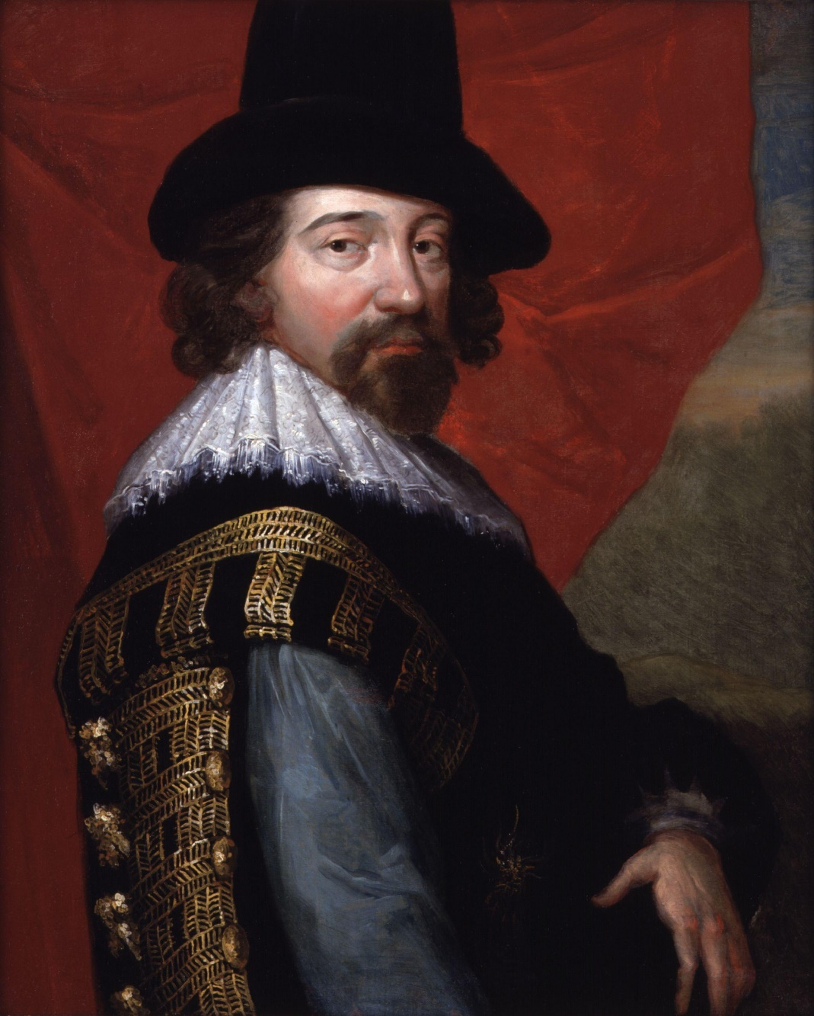

Francis Bacon (28 October 1909 – 28 April 1992) was an Anglo-Irish figurative painter known for his bold, emotionally charged and raw imagery. His painterly abstracted figures are typically isolated in glass or steel geometrical cages, set against flat, nondescript backgrounds. Bacon took up painting in his early 20s but worked sporadically and uncertainly until his mid-30s. Unsure of his ability, he drifted as a highly complex bon vivant, homosexual, gambler and interior decorator and designer of furniture, rugs and bathroom tiles. He later admitted that his artistic career was delayed because he spent too long looking for subject matter that could sustain his interest. His breakthrough came with the 1944 triptych Three Studies for Figures at the Base of a Crucifixion, which in the immediate aftermath of the Second World War, sealed his reputation as a uniquely bleak chronicler of the human condition. Remarking on the cultural significance of Three Studies, John Russell observed that "there was painting in England before the Three Studies, and painting after them, and no one...can confuse the two."

Bacon was equally reviled and acclaimed during his lifetime. Margaret Thatcher described him as "that man who paints those dreadful pictures", but he was the subject of two Tate retrospectives and a major showing in 1971 at the Grand Palais. Since his death his reputation and market value have grown steadily, and his work is amongst the most acclaimed, expensive and sought-after. In the late 1990s a number of major works, previously assumed destroyed, including early 1950s popes and 1960s portraits, reemerged to set record prices at auction. On 12 November 2013 his Three Studies of Lucian Freud set the world record as the most expensive piece of art sold at auction, selling for $142,405,000, until exceeded by the sale of a Picasso in May 2015.

* + 1. **Study after Velázquez's Portrait of Pope Innocent X**

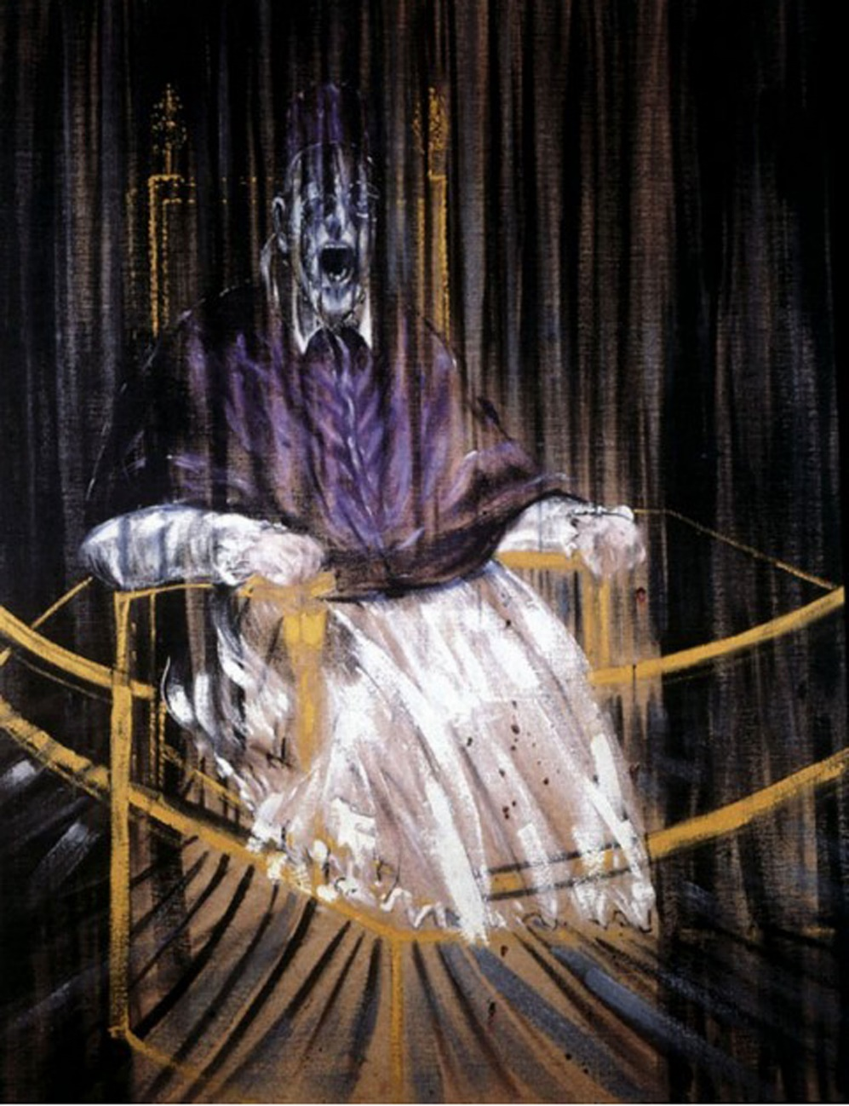

Study after Velázquez's Portrait of Pope Innocent X is a 1953 painting by the artist Francis Bacon. The work shows a distorted version of the Portrait of Innocent X painted by Spanish artist Diego Velázquez in 1650. The work is one of a series of over 45 variants of the Velázquez painting which Bacon executed throughout the 1950s and early 1960s. The picture was described by Gilles Deleuze as an example of creative re-interpretation of the classical

When asked why he was compelled to revisit the subject so often, Bacon replied that he had nothing against the Popes, that he merely sought "an excuse to use these colours, and you can't give ordinary clothes that purple colour without getting into a sort of false fauve manner."

In Bacon's version of Velázquez's masterpiece, the Pope is shown screaming yet his voice is "silenced" by the enclosing drapes and dark rich colors. The dark colors of the background lend a grotesque and nightmarish tone to the painting. The pleated curtains of the backdrop are rendered transparent and appear to fall through the representation of the Pope's face.

* + 1. **Three Studies for Figures at the Base of a Crucifixion**

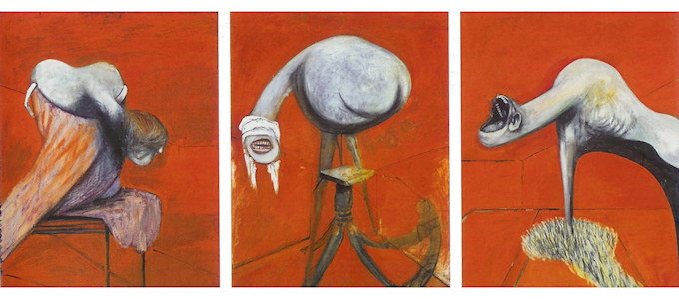

Three Studies for Figures at the Base of a Crucifixion is a 1944 triptych painted by the Irish-born British artist Francis Bacon. The work is based on the Eumenides—or Furies—of Aeschylus's The Oresteia, and depicts three writhing anthropomorphic creatures set against a flat burnt orange background. Three Studies was executed in oil paint and pastel on Sundeala fibre board and completed within two weeks.

The triptych summarises themes explored in Bacon's previous paintings, including his examination of Picasso's biomorphs and his interpretations of the Crucifixion and the Greek Furies. Bacon did not realise his original intention to paint a large crucifixion scene and place the figures at the foot of the cross.

The Three Studies triptych is generally considered Bacon's first mature piece; he regarded his works before the triptych as irrelevant, and throughout his life tried to suppress their appearance on the art market. When the painting was first exhibited in 1945 it caused a sensation and helped to establish him as one of the foremost post-war painters. Remarking on the cultural significance of Three Studies, the critic John Russell observed in 1971 that "there was painting in England before the Three Studies, and painting after them, and no one ... can confuse the two."

* 1. **Franz Marc**

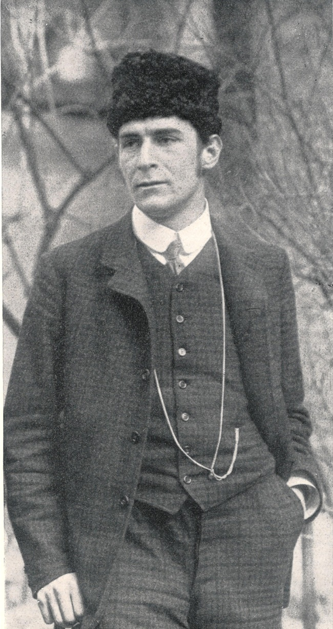

Franz Marc (February 8, 1880 – March 4, 1916) was a German painter and printmaker, one of the key figures of the German Expressionist movement. He was a founding member of Der Blaue Reiter (The Blue Rider), a journal whose name later became synonymous with the circle of artists collaborating in it.

Marc made some sixty prints in woodcut and lithography. Most of his mature work portrays animals,[3] usually in natural settings. His work is characterized by bright primary color, an almost cubist portrayal of animals, stark simplicity and a profound sense of emotion. Even in his own time, his work attracted notice in influential circles. Marc gave an emotional meaning or purpose to the colors he used in his work: blue was used to portray masculinity and spirituality, yellow represented feminine joy, and red encased the sound of violence.

* + 1. **Tierschicksale, The Fate of the Animals**

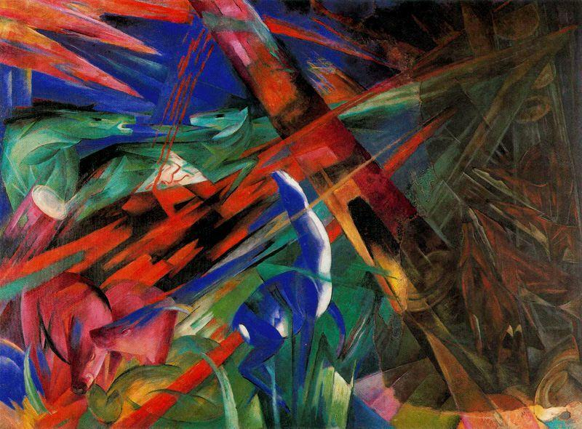

Fate of the Animals is a painting by Franz Marc created in 1913. It is oil on canvas. This work contrasts most of Marc's other works by presenting animals in a brutal way rather than depicting them in a peaceful manner. Marc's strong ties with animals as his subjects remains uncertain, but it is predicted to stem from his childhood dog. Fate of the Animals remains one of Marc's most famous pieces and displays Der Blaue Reiter style that he co-founded with Wassily Kandinsky. The painting currently resides in the Kunstmuseum in Basel, Switzerland.

This work is also characteristic of the sense of apocalypse and doom which began to taint Marc's work at this time and could be related to his feelings on the impending war. In a 1915 letter to his wife Maria, Marc explains that this change in his art occurred because he began to see the ugliness in animals which he had previously thought only existed in humans. He states that he was no longer able to see the beauty which animals had once represented for him. The animal motifs which once conveyed a sense of emotion no longer held their appeal and possibility. The application of paint and the division of the picture plane through the use of lines and geometric shapes now carried the emotional charge previously conveyed by animals. This change may be related to Marc's ideas on the impending war. In apprehension of the First World War, Marc was part of the school of thought that the war would purify and redeem the universe of all that was bad. Marc no longer saw animals as separate entities in their own perfect kingdom, as he had once represented them. At the point when Marc began to identify the ugliness in animals, he recognized them as part of the universe which man also inhabited and which was in need of redemption.

* + 1. **The Red Horses**

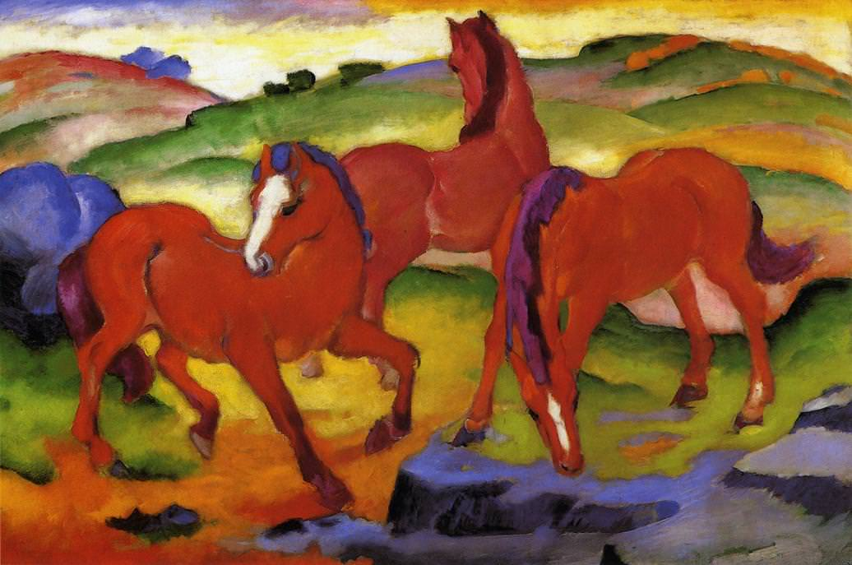

Marc wrote: "Every color must say clearly 'who and what it is, and must, moreover, be related to a clear form."

In Red Horses, the depiction is sufficiently simplified so as to allow the color to be paramount. The dynamic red of the horses suggested that Marc intended to emphasize an earthly orientation for this particular group of animals. The white area surmounting the pyramidally arranged horses can be understood as symbolizing purity or solace in comparison to the rest of the canvas. To interpret Marc's use of green in the upper third of the painting with regard to his thoughts on color is also enlightening. He said that once green in introduced, "You never entirely bring the eternally material, brutal red to rest." In that spirit, the horses seem nervous beyond all possibility of resolution. Only the blue, as Marc prescribed, lends a peaceful note to the agitated atmosphere.

* 1. **Paul Klee**

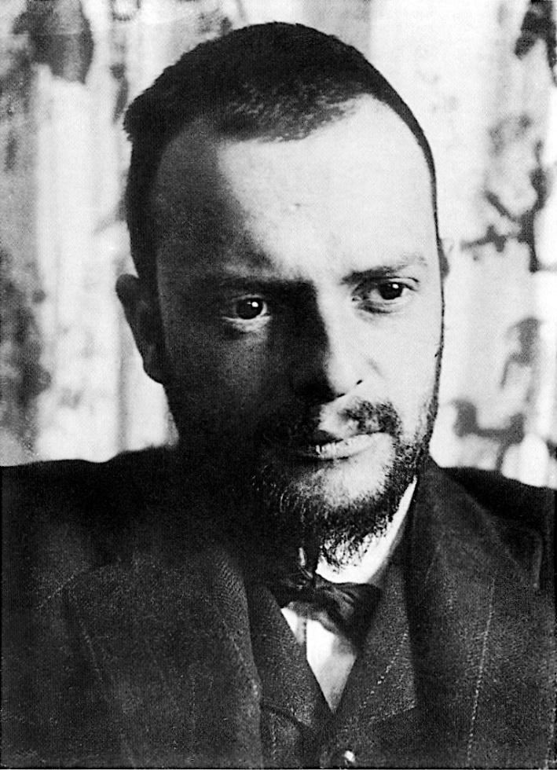

Paul Klee (18 December 1879 – 29 June 1940) was a Swiss-German painter. His highly individual style was influenced by movements in art that included expressionism, cubism, and surrealism. Klee was a natural draftsman who experimented with and eventually deeply explored color theory, writing about it extensively; his lectures Writings on Form and Design Theory (Schriften zur Form und Gestaltungslehre), published in English as the Paul Klee Notebooks, are held to be as important for modern art as Leonardo da Vinci's A Treatise on Painting for the Renaissance. He and his colleague, Russian painter Wassily Kandinsky, both taught at the Bauhaus school of art, design and architecture. His works reflect his dry humor and his sometimes childlike perspective, his personal moods and beliefs, and his musicality.

Klee has been variously associated with Expressionism, Cubism, Futurism, Surrealism, and Abstraction, but his pictures are difficult to classify. He generally worked in isolation from his peers, and interpreted new art trends in his own way. He was inventive in his methods and technique. Klee worked in many different media—oil paint, watercolor, ink, pastel, etching, and others. He often combined them into one work. He used canvas, burlap, muslin, linen, gauze, cardboard, metal foils, fabric, wallpaper, and newsprint. Klee employed spray paint, knife application, stamping, glazing, and impasto, and mixed media such as oil with watercolor, watercolor with pen and India ink, and oil with tempera.

* + 1. **Twittering machine**

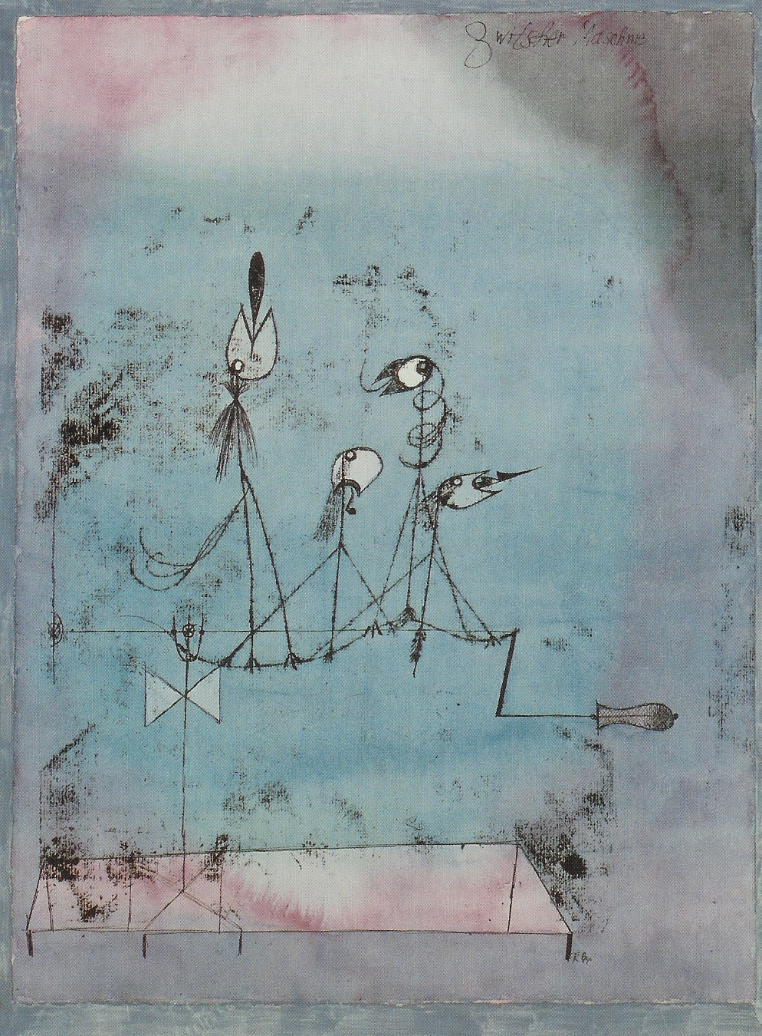

Twittering Machine (Die Zwitscher-Maschine) is a 1922 watercolor and pen and ink oil transfer on paper by Swiss-German painter Paul Klee. Like other artworks by Klee, it blends biology and machinery, depicting a loosely sketched group of birds on a wire or branch connected to a hand-crank. Interpretations of the work vary widely: it has been perceived as a nightmarish lure for the viewer or a depiction of the helplessness of the artist, but also as a triumph of nature over mechanical pursuits. It has been seen as a visual representation of the mechanics of sound.

The picture depicts a group of birds, largely line drawings; all save the first are shackled on a wire (or, according to The Washington Post, a "sine-wave branch") over a blue and purple background which the MoMA equates with the "misty cool blue of night giv[ing] way to the pink flow of dawn". Each of the birds is open-beaked, with a jagged or rounded shape emerging from its mouth, widely interpreted as its protruding tongue. The end of the perch dips into a crank.

The bird with an exclamation point in its mouth represents the twitter's full volume; the one with an arrow in its beak symbolizes an accompanying shrillness – a horizontal thrust of piercing song. Since a characteristic of chirping birds is that their racket resumes as soon as it seems to be ending, the bird in the center droops with lolling tongue, while another begins to falter in song; both birds will come up again full blast as soon as the machine's crank is turned.

* + 1. **Senecio**

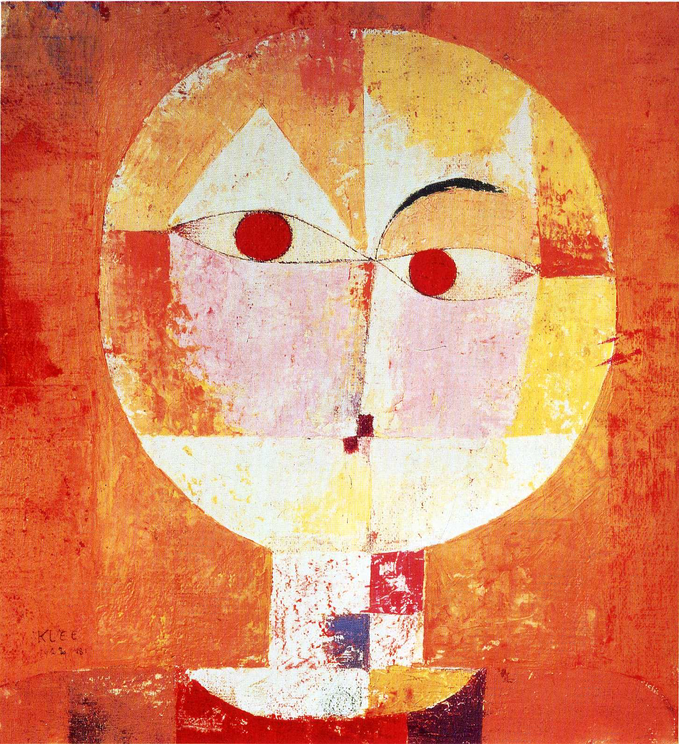

Type: oil on canvas

Completed in 1922, Senecio is a manifestation of Paul’s sense of humor and African culture. The simple colors and shapes, Paul makes use of various shades of orange, red, and yellow to reveal portrait of an old man. Artistic use of shapes gives the false impression that one eye browse is raised. His left eye brow is represented by a triangle while the other one is made of a simple curved line. The portrait is also called Head of a Man Going Senile and intentionally mimics children’s artwork by using ambiguous shapes and forms with minimal facial details.